
lAB 5 – bUILD A dATABASE sERVER
Timothy Victori

Timothy Victori
Engineering Department Arizona State University
IFT320: Managing the Cloud
Rahul Kashyap
April 13, 2025

Lab 5 – Build a Database Server
Figure 1
A screenshot of lab being submitted
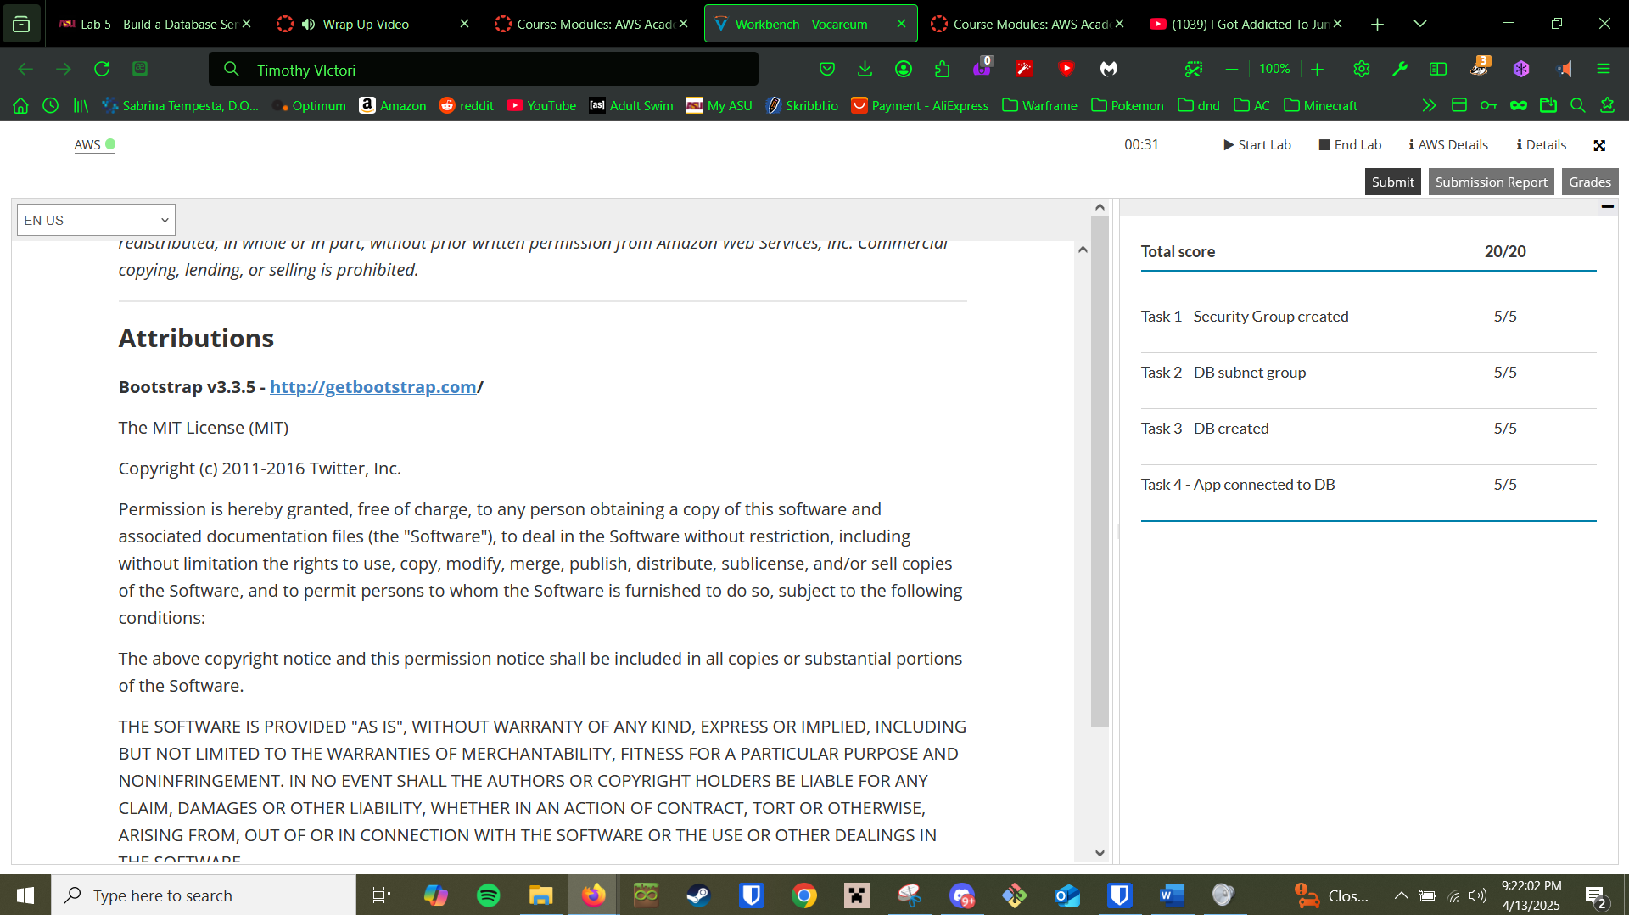 Q

